Experiment no: - 3
Experiment Name: - Basic SQL Retrieval Statements-Selection (where), Projection (Select) and functions.

Aim: -Performing practical by using Basic Retrieval Statements, restricting data and built-in Function

PART B
(PART B: TO BE COMPLETED BY STUDENTS)

(Students must submit the soft copy as per following segments within two hours of the practical. The soft copy must be uploaded on the Blackboard or emailed to the concerned lab in charge faculties at the end of the practical in case the there is no Black board access available)

Roll. No.: C-60 | NAME: Avdhut Madhavi
Class: C | Batch:C2
Date of Experiment: | Date of Submission:
Grade:

B.1: Read the given question carefully and write a SQL statement and check the output.
(Put the query and its output after each question.)

To perform practical operations using basic SQL retrieval statements, restrict data using the WHERE clause, and apply built-in functions on the Population Management System database.

1. Display all records from the customer table

SELECT * FROM customer;

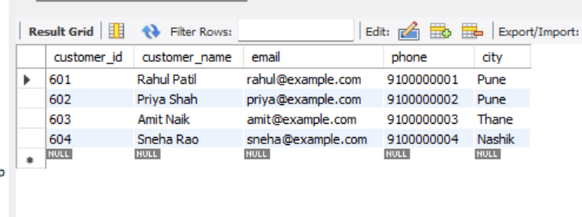

Explanation: Displays all columns and records in the customer table.

2. Display selected columns (projection)

SELECT customer_id, customer_name, city, email
FROM customer;

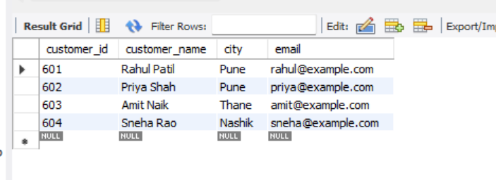

Explanation: Displays only the customer ID, name, city and email columns.

3. Display unique customer genders

SELECT DISTINCT city
FROM customer;

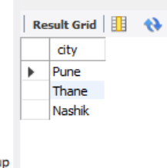

Explanation: Displays each unique city without duplicates.

4.Display customers whose ID is greater than 602

SELECT customer_id, customer_name, city
FROM customer
WHERE customer_id > 602;

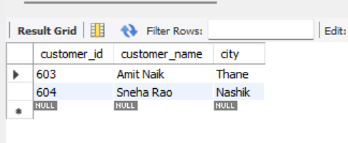

Explanation: Displays customers whose IDs are greater than 602.

5. Display customers whose IDs are between 601 and 604

SELECT customer_id, customer_name, city
FROM customer
WHERE customer_id BETWEEN 601 AND 604;

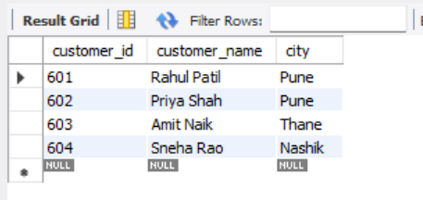
Explanation: BETWEEN includes both boundary values.

6. Display customers from selected cities

SELECT customer_id, customer_name, city
FROM customer
WHERE city IN ('Mumbai', 'Pune', 'Thane');

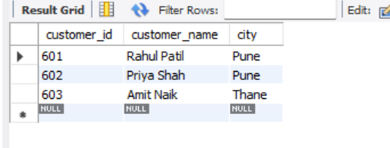

Explanation: Retrieves customers whose addresses match any of the listed cities.

7. Search customer names using LIKE

SELECT customer_id, customer_name
FROM customer
WHERE customer_name LIKE 'R%';

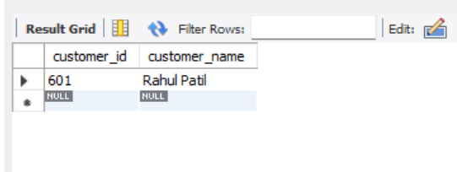

Explanation: Displays customers whose names begin with the letter R.

8. Use logical operators AND and OR

SELECT customer_id, customer_name, city
FROM customer
WHERE (city = 'Mumbai' OR city = 'Pune')
AND customer_id > 601;

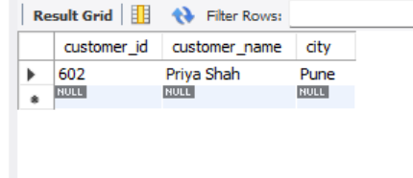

Explanation: Displays customers from Mumbai or Pune whose IDs are greater than 601.

9. Use the NOT operator

SELECT customer_id, customer_name, city
FROM customer
WHERE city NOT IN ('Mumbai', 'Pune');

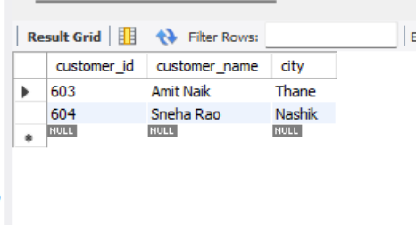

Explanation: Displays customers whose addresses are neither Mumbai nor Pune.

10. Sort customers by customer ID

SELECT customer_id, customer_name, city
FROM customer
ORDER BY customer_id ASC;

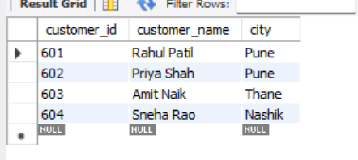

Explanation: Displays customers in ascending order of customer ID.

11. Use character functions

SELECT
customer_name,
UPPER(customer_name) AS uppercase_name,
LOWER(customer_name) AS lowercase_name,
LENGTH(customer_name) AS name_length
FROM customer;

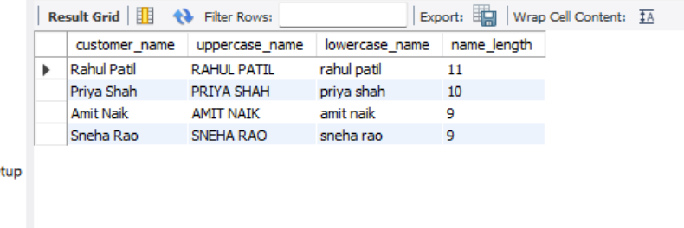

Explanation: Demonstrates uppercase conversion, lowercase conversion, and name-length calculation

12. Use number functions

SELECT
ticket_price,
ROUND(ticket_price / 3, 2) AS divided_price,
MOD(ticket_price, 2) AS price_remainder
FROM showtime;

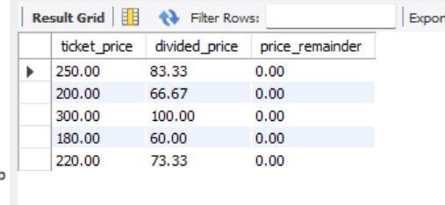

Explanation: Demonstrates ROUND() and MOD() using ticket prices.

13. Use date functions

SELECT
show_id,
show_date,
DATE_ADD(show_date, INTERVAL 1 MONTH) AS next_month_date,
LAST_DAY(show_date) AS month_end
FROM showtime;
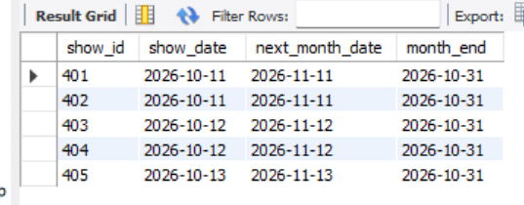

Explanation: Displays the show date, the date one month later, and the last day of the show date's month.

14. Use conversion and general functions

SELECT
show_id,
DATE_FORMAT(show_date, '%d-%b-%Y') AS formatted_date,
IFNULL(show_time, 'Not Available') AS show_time
FROM showtime;

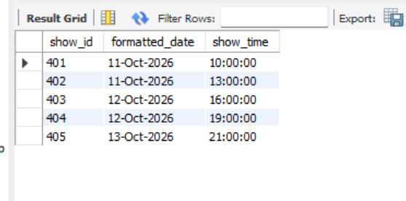

Explanation: Formats dates as text and replaces any NULL status with Not Available.

B.2. Observation

The SELECT statement was used to retrieve records from the Cinema Ticket Booking System tables. The WHERE clause restricted records according to specified conditions. The DISTINCT keyword eliminated duplicate values, and ORDER BY arranged records in ascending order. Comparison and logical operators were used to filter data. Character, number, date, and conversion functions were applied to retrieve and process information from the database.
Result: Basic SQL retrieval statements, selection, projection, sorting, and built-in functions were successfully practised using MySQL Workbench.

B2 - Write answers to the following-
Q1.Explain the structure of a SELECT statement. List and describe its main clauses.
The SELECT statement retrieves data from one or more database tables.
SELECT column_name
FROM table_name
WHERE condition
ORDER BY column_name;
- SELECT: Specifies the columns to retrieve.
- FROM: Specifies the table.
- WHERE: Filters rows according to a condition.
- ORDER BY: Sorts the result.
- DISTINCT: Removes duplicate rows from the result.

Q2. Differentiate between DISTINCT and ALL with suitable examples.

DISTINCT | ALL
Returns only unique values or rows. | Retains duplicate values or rows.
Eliminates duplicates. | Does not eliminate duplicates.
Must be specified when required. | Default behavior when neither keyword is specified.

Q3.Explain the role of the WHERE clause in SQL. How does it help in restricting data?

The WHERE clause filters records based on a specified condition. It returns only those rows that satisfy the condition.
Ex: -
SELECT *
FROM customer
WHERE city = 'Pune';

Q4.Differentiate between the operators used in WHERE clause:
- Comparison operators: =, >, <, >=, <=, <>. They compare values.
- Logical operators: AND, OR, NOT. They combine or reverse conditions.

Example:
SELECT *
FROM customer
WHERE city = 'Mumbai'
AND customer_id > 601;

Q5.What are built-in (aggregate) functions in SQL? Explain COUNT(), SUM(), AVG(), MAX(), MIN() with their purpose.
Aggregate functions calculate a result from a group of rows.

Function | Purpose | Example
COUNT() | Counts records or non-NULL values. | COUNT(*)
SUM() | Calculates the total. | SUM(ticket_price)
AVG() | Calculates the average. | AVG(ticket_price)
MAX() | Returns the highest value. | MAX(ticket_price)
MIN() | Returns the lowest value. | MIN(ticket_price)

